**STATA J2R placebo**

mimix hamd17total treatmentname,id(patientnumber) time(visitnumber) covar(basval pooledinvestigator sex ) method(J2R) ref(PLACEBO)

> m(100) seed(101) regress clear

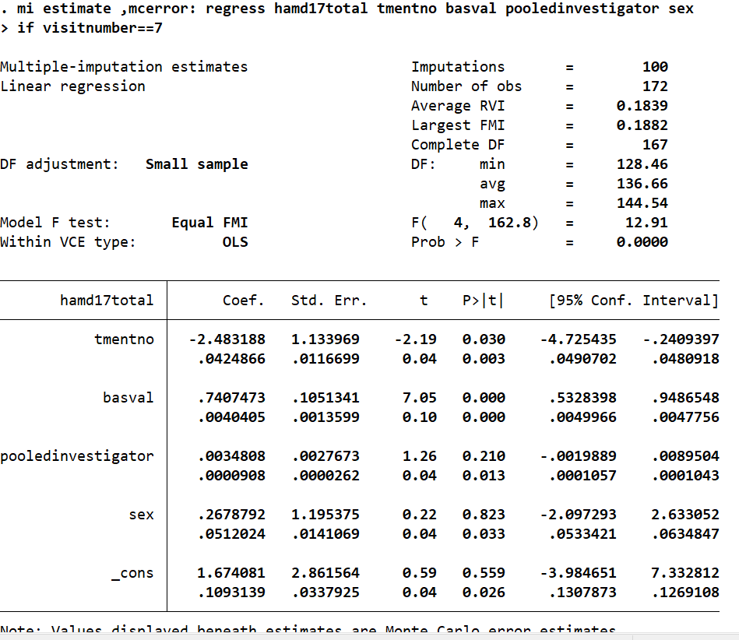

**R output J2R placebo**

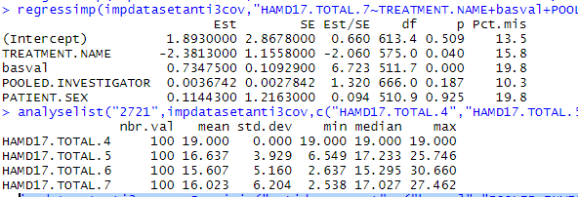

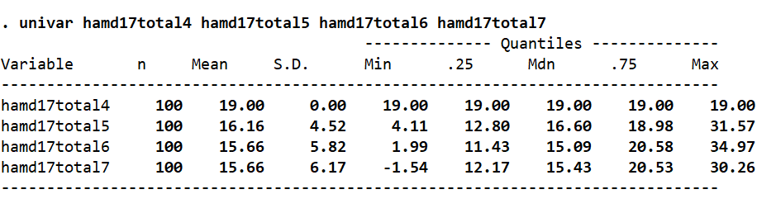

**STATA J2R Drug**

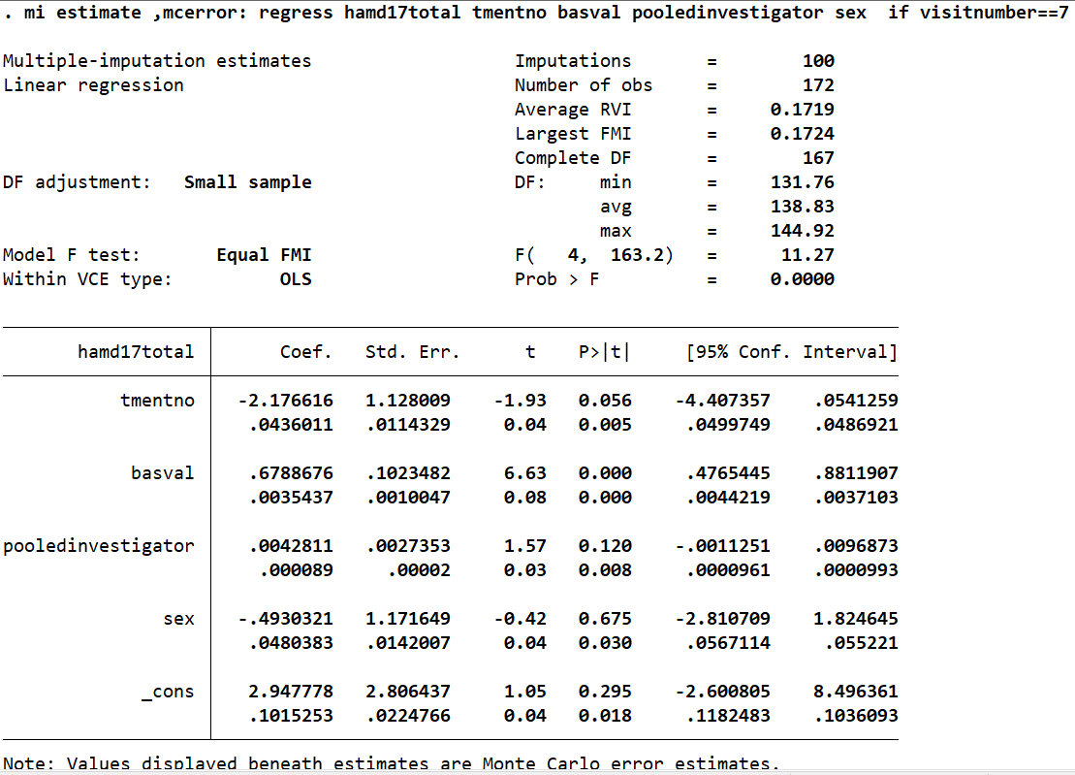

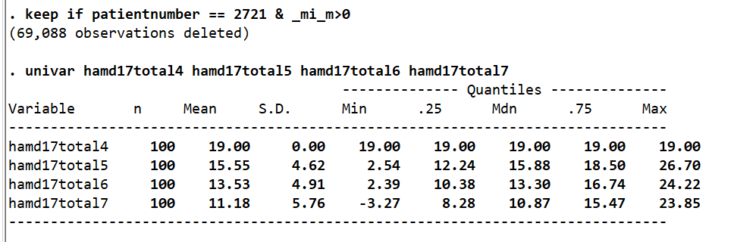

**R output J2R Drug**

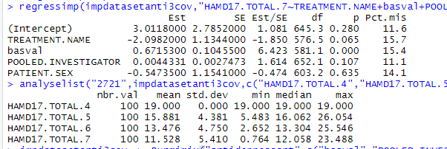

**Causal**

impanticausal <- mimix("antidepressant",c("basval","POOLED.INVESTIGATOR","PATIENT.SEX"),"HAMD17.TOTAL","TREATMENT.NAME","PATIENT.NUMBER","VISIT.NUMBER",100,1,"Causal",101,c("jeffreys"),1000,NULL,NULL)

Kd = 0

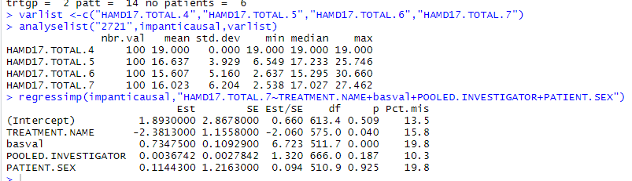

Kd =1

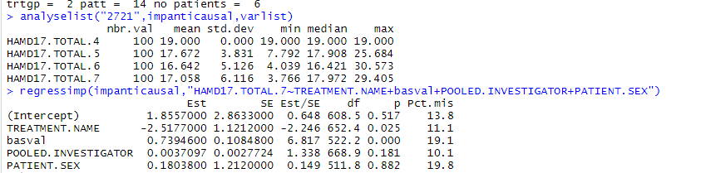

Kd=2

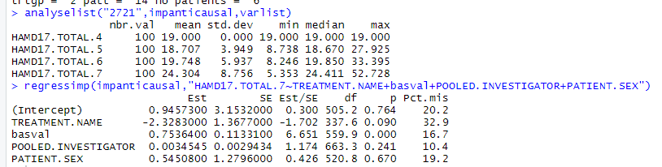

Kd=0 (same as J2R) with delta c(0.5,0.5,1,1)

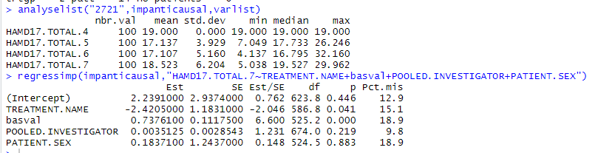

Kd=0 (same as J2R) no delta

